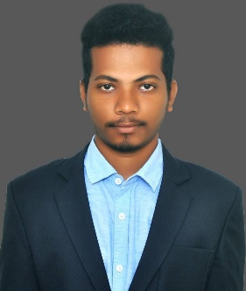 **SYAM SUNDAR YADLA**

Employee Id: 2110545

LinkedIn: [https://www.linkedin.com/in/s](https://www.linkedin.com/in/satyadev-ch-0a581420b/)hyam-yadla-8a01191b4

+91 7731907715

yadla.syamsundar@cognizant.com

Creer Objective

To build career in a growing organization, where I can get the opportunities by accepting the challenges, fulfilling the organizational goal and climb the career ladder through continuous learning and commitment.

Education

|  |  |  |  |  |
| --- | --- | --- | --- | --- |
| **Qualification** | **University / Institute** | **University / Board** | **Year of Passing** | **Percentage/ CGPA** |
| B. Tech  (ECE) | Vel Tech  University | Vel Tech, Chennai | 2022 | 8.79 |
| XII | Aditya Junior College | Intermediate | 2018 | 95% |
| X | Abhyas the Global School | CBSE | 2016 | 10.0 |

Skills

|  |  |
| --- | --- |
| Language | Java, HTML, CSS, JavaScript, ReactJs |
| Skills | Manual testing, Automation, Developing Web Applications |
| Tools | Eclipse, Visual Studio Code |

Experience

* Good Knowledge in Software Development Life cycle, Software Testing Life cycle.
* Expertise in **Manual Testing Concepts**.
* Hands on experience in automation testing using **Java- Selenium.**
* Good Knowledge in Selenium **Web driver.**
* Gained Knowledge in writing **XPATH** for web elements.
* Developing Web Applications in ReactJS using HTML, CSS and JS and developed web applications like Weather App, Movie App, Social Media App and Eceommerce Application.

Projects

* Worked In MIR[Mortgage Imaging Repository] program under US Bank, as a manual tester for backend functionality.
* I have worked in Folder Migration department, to check the data for the migrated loans using the SQL - Queries from the Database.

Certifications

* MicroSoft Azure Fundamentals (AZ-900).
* Frontend Certification (HTML, CSS, JavaScript, ReactJs).